**System Design**

**Employee Management**

* Add Employees
* View Employee List
* Update Employees
* Delete Employees

**Department Management**

* Add Departments
* View Department List
* Update Departments
* Delete Departments

**Front End**

User

React JS

**Back End**

**Application Logic**

ASP .Net Core

**Web Server**

**Database**



Microsoft SQL Server

Department Table  
Employee Table

**UI Design**

**Wireframes**

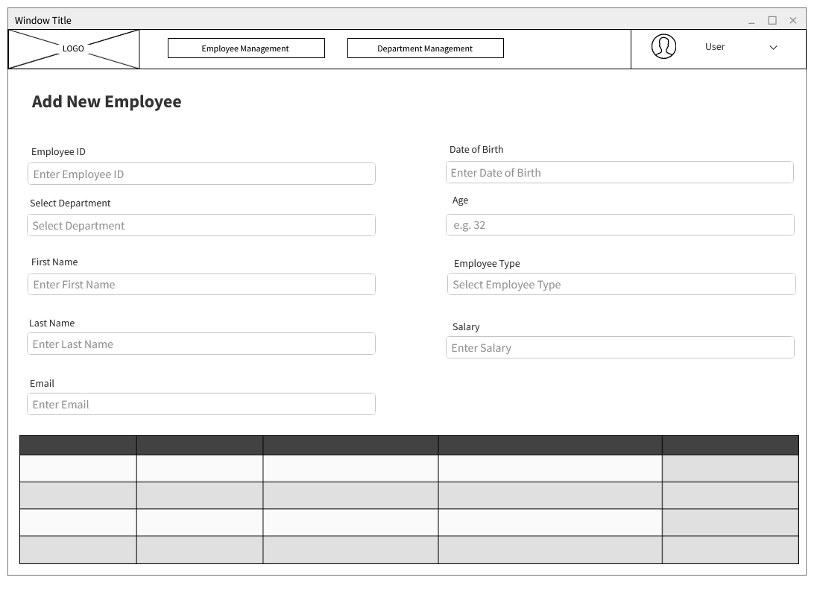

**Interfaces:**

**Interface 01 – Employee Management**

**Add new employee**

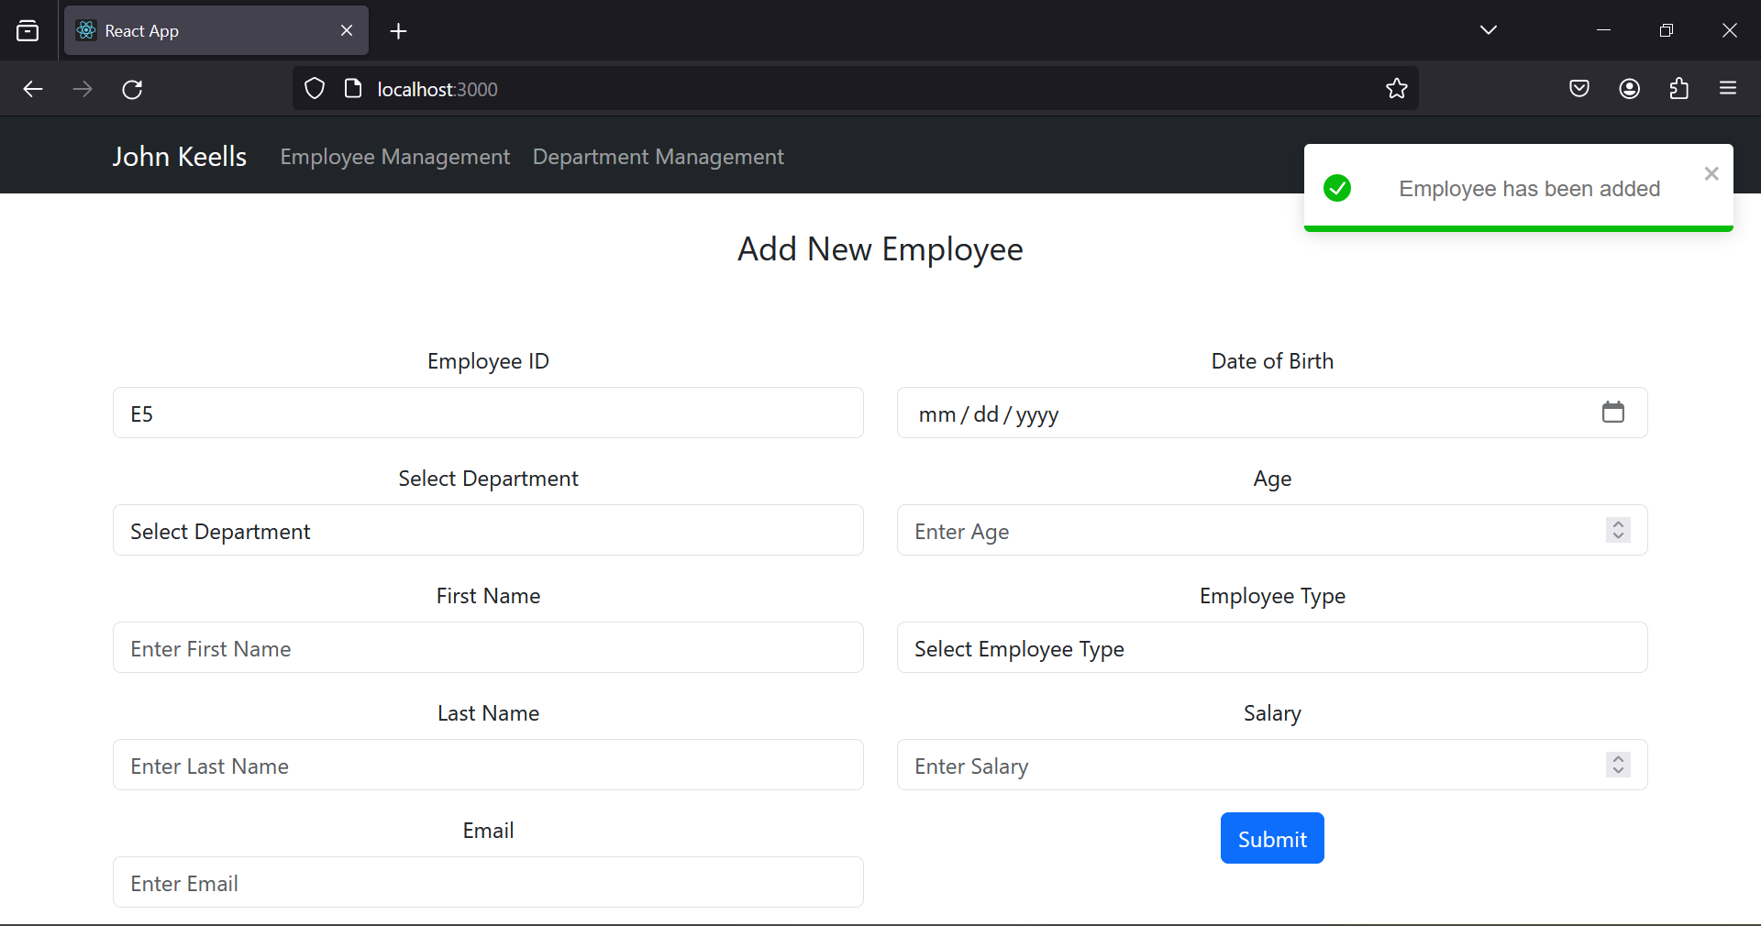

**Delete employee**

**Edit employee**

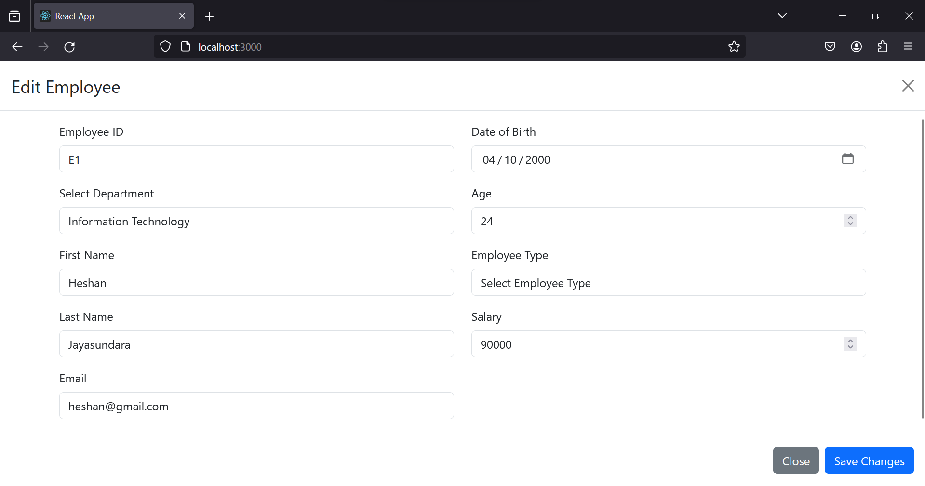

**Interface 02 – Department Management**

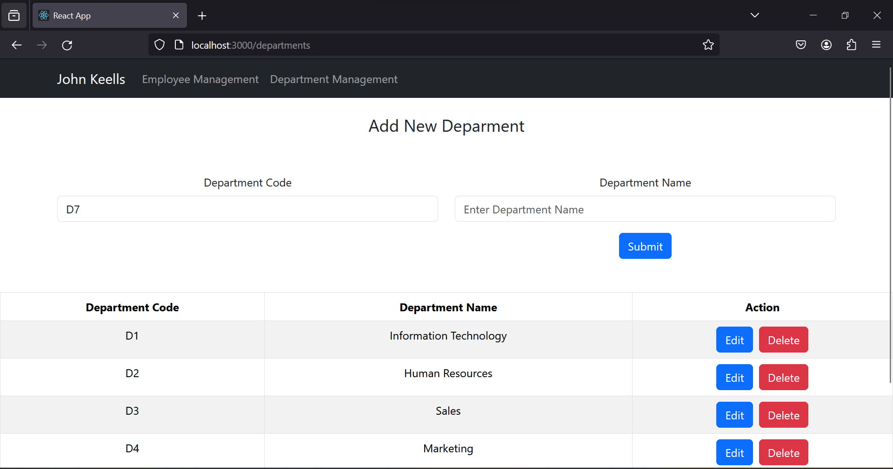

**Add new department**

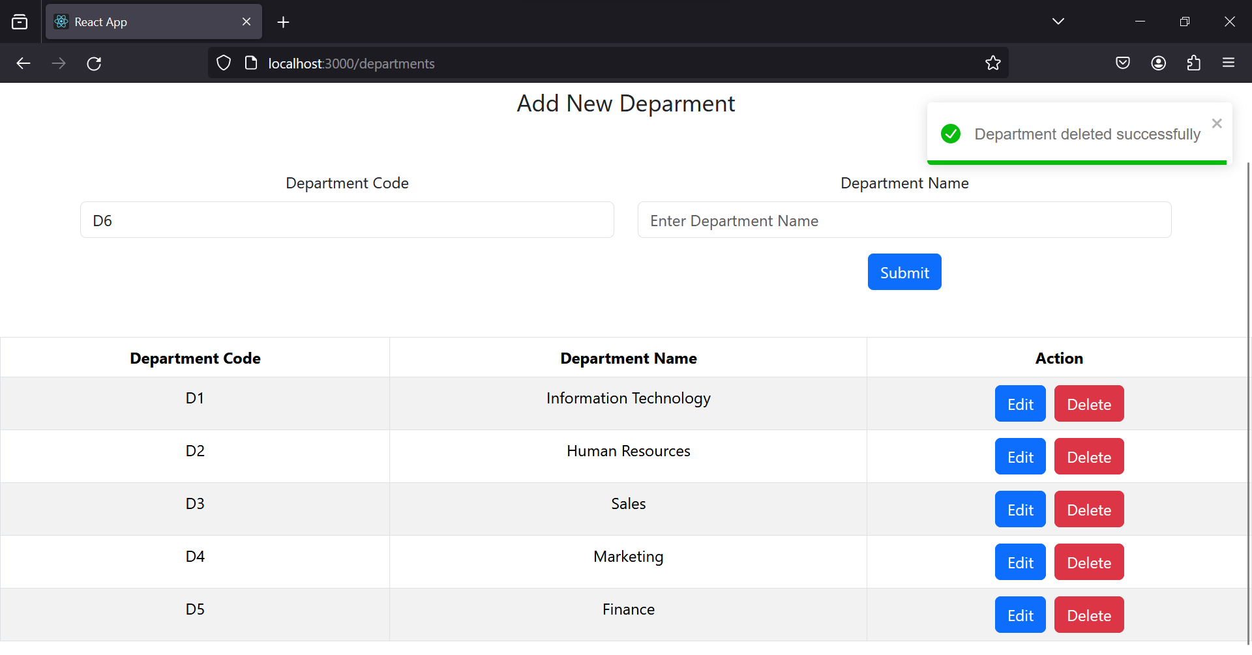**Delete Department**

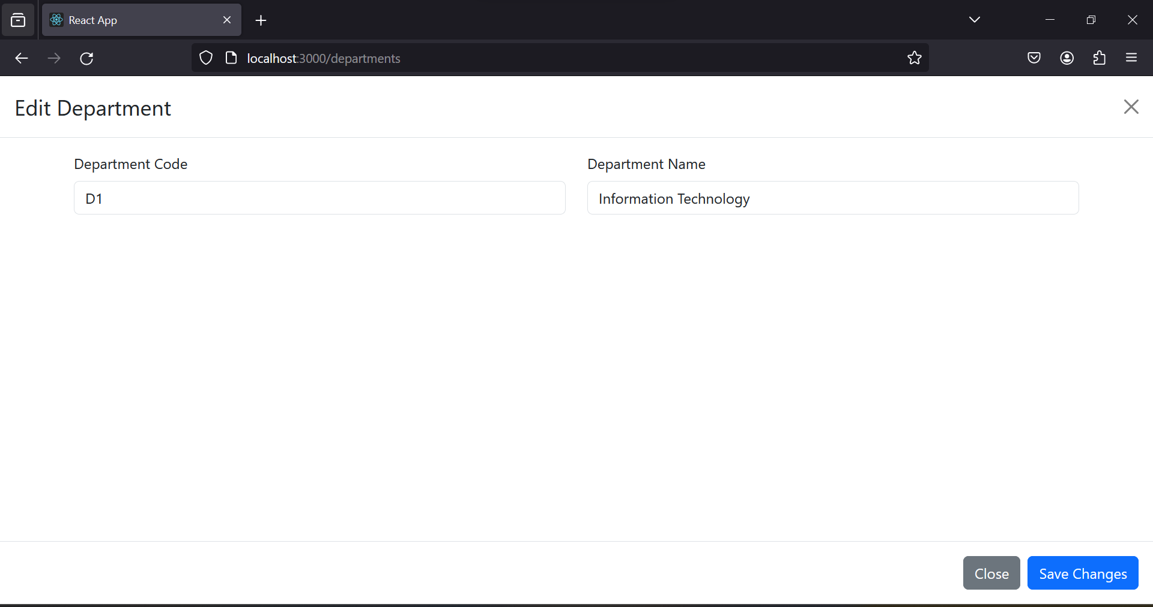**Edit Department**

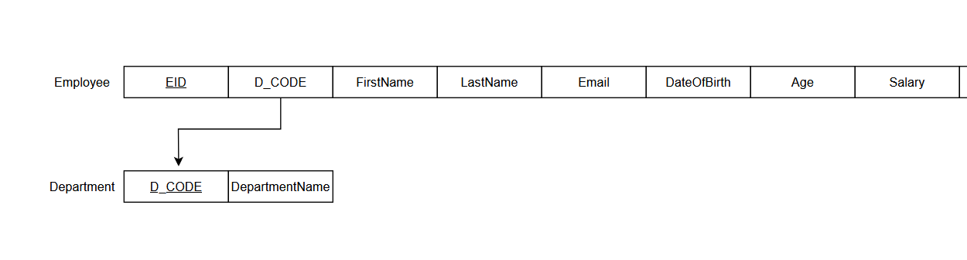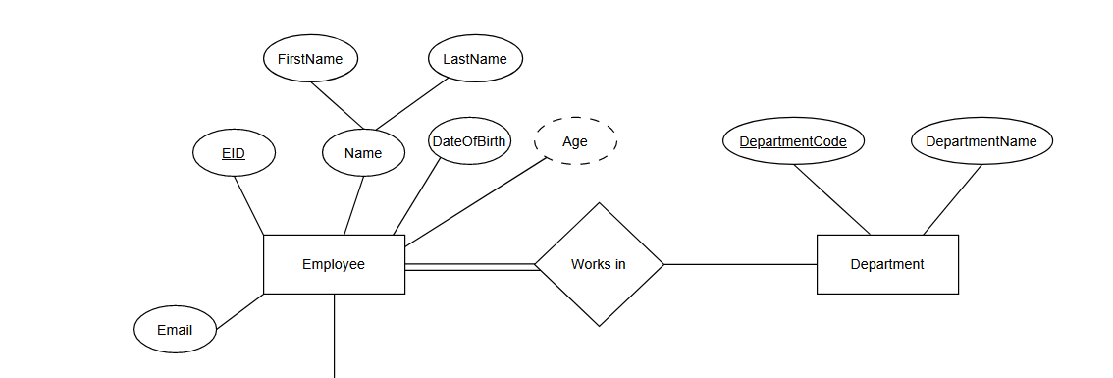**Database Design**

Employee Type

Relational Schema

Employee Type

Salary

ER Diagram